Viral Micro parasite Model with Distributed delay

1Appa RaoD 2Kalesha Vali S and3Paparao A V

1Department of Mathematics, IIIT Srikakulam, RGUKT-AP

[appuhcu2007@gmail.com](mailto:appuhcu2007@gmail.com),

2, 3 Department of Mathematics, JNTUK, University College of Engineering

Vizianagarm-535003, India

[valijntuv@gmail.com](mailto:valijntuv@gmail.com),

[paparao.alla@gmail.com](mailto:paparao.alla@gmail.com)

**Abstract:**

In this paper we analyze the stability analysis of directly transmitted viral micro parasite model which includes susceptible(x), infective(y) and immune (z) populations. The total population N is given by the sum of three populations (N=x + y +z). A distributed type of delay is incorporated in the interaction of susceptible (x) and infective (y) populations. The model is represented by the system of nonlinear integro-differential differential equations. We observed that the model possessed a unique endemic equilibrium point and studied the system dynamics at this point using two delay kernels. The system is asymptotically stable if. Numerical simulation is carried out using MATLAB with two delay kernels in support of stability analysis.

**Keywords:** Equilibrium points, Local stability, Numerical simulation, Delay argument.

1. **Introduction:**

Mathematical modelling gains a lot of importance in the recent era due to its interdisciplinary nature. Epidemiology is the study and analysis of epidemics in human population which determines the conditions of the disease. The dissemination of infectious diseases have been a considered a very grave and a dangerous for the well being of the human race. Infectious diseases lead to serious issues for the survival of the individuals and of varied species. It also impacts in regards the money related and social improvement concerns of the human race. In the recent decades it gains a lot of importance .Mathematical models are well known to describe the nature of the diseases (epidemics), in this scenario the differential equations play a vital role in clarifying the epidemic models.

**1.1 Literature Review**

Delays are common in epidemic models .They play a very a vital role especially in epidemic models because they alter the system from stable to unstable and vice versa. Kuang, (1993) describes the applications of delay differential equations which arise in population dynamics. Anderson, and May, (1979; 1981) studied the various epidemic models and their stability analysis. Epidemiology is the study of diseases causation, transmission of diseases, outbreak of disease etc. Epidemiology also deals with the dynamics of the parasites and the host population interaction. The mathematical analysis on epidemiology was dealt by Brauer, Driessche, & Wu, (2008), (Daley, & Gani, 1999) and (Frauenthal, 1980). (Murray, 2002). who discussed the various models and dynamics of ecology and epidemiology. Transmission of diseased dynamics is the driving force behind the overall population dynamics of pathogens, studied by (Bayley, 1975). The stability analysis of vector born diseased models are studied by (Cooke, 1979).

The dynamics of viral Infections of humans, the stability analysis communicable disease models are respectively studied by (Evans, 1982) and (Hethcote, 1976). These diseases are controlled by vaccination. The models which deal with pulse vaccination and control of viral infection is studied by Nokes, & Swinton, (1995). The communicable diseases like HIV and the CTL responses with time delay was studied by Karuna, Narayan, & Ravindra Reddy, (2015).

Zhou, & Cui, (2011) discussed the global stability analysis of viral diseases. The environment is also having its impact in spreading the viral diseases. The stochastic influences with respect to epidemiology were dealt by Kumar, Narayan, & Ravindrareddy, (2017).In addition to this Rao, Vali, & Paparao, (2017) studied the dynamics of directly transmitted viral micro parasite model. The system dynamics was completely studied and shown that the system is asymptotically stable .The model equations are given by the system of differential equations as follows

 (1.1)

In this study we also include the distributed type of delay which incorporated in micro parasite model which is shown in equation (2.1) .In this work we explore the dynamics and existence of solutions by using analytical and simulation approaches.The study of distributed type delay models normalization procedure equation (2.2) with delay kernels approach equations (2.3) and (2.4) was dealt by Paparao, & Narayan, (2017) who described distributed type of time delay models in population dynamics. The same approach was taken to elaborate the system (2.1).

The dynamics of system (1.1) is asymptotically stable if . The system (2.1) with the delay kernels is asymptotically stable if  . More over the kernel strengths play a significant role which is in detailed explained using numerical simulation.

1. **Mathematical Model**

A micro parasite model is considered for the investigation of susceptible (x), infective (y) and removable (z) populations. A distributed type of delay is incorporated in the interaction of susceptible and infective population .The total population (N) is constant in view of births and deaths. The model is characterized by the system of integro differential equations. The governing equations of the system are as follows.

(2.1)

Where Nis the total population given by N = (x + y + z),

x : susceptible population, y: infectious population, z : Removable population

Transmission rate, b: birth and death rate of population

r: is recovery rate of infection , w1&w2 are weight kernels

The infection spread out that is the thresh hold transmission if the basic reproductive number R0>1 and dies out eventually if R 0≤1. The threshold population size Nc is given by and if the total population N < Nc, we identified that the parameters for threshold transmission rate (R0≤1) and threshold population size N < Nc,for which the parasite cannot maintain itself i.e., in the population eventually dies out the removable and infective class.

Substitute t-u = z , then the system of equations (2.1) becomes

 (2.2)

The weight kernels w1(z) , w2(z) can be satisfies the following relations

 (2.3)

Assume the solutions x(t) , y(t) , z(t) are exponential type such that  and substitute in the system of equations (2.2) we get the following is given by

 (2.4)

Where  Laplace is transforms of  respectively.

1. **Equilibrium points:**

These are obtained by solving the equations in (2.1) after equating them individually to zero i.e.,

1. Disease free equilibrium point E1 is (N, 0, 0) (3.1)
2. Endemic equilibrium point (E2) is 

(3.2)

1. **Local stability of analysis:**

Theorem: The Endemic equilibrium point is locally asymptotically stable if.

Proof: The variational matrix for the system is 

The characteristic equation is given by

 (4.1)

Where

 (4.2)   
**Case (i).** Choose the delay kernel weights as  then



Using Routh-Hurwitz criteria we can calculate the following determinants by substituting

 in equations (4.2) we get 





The three determinants  are positive if 

Hence the endemic equilibrium point is locally asymptotically stable if.

**Case (ii).** Choose the delay kernel weights as  then



Using Routh - Hurwitz criteria we can calculate the following determinants by substituting  in equations (4.2) we get







The three determinants  are positive if 

Hence the endemic equilibrium point is locally asymptotically stable if.

**6. Numerical example:**

**Case (i) :** Using the kernel weights kernel weights as  the results are simulated using MATLAB for the following set of parametric values.

**Example I:** b=0.1, r = 8, β = 0.2, x = 80, y = 40, z = 20

For different values of λ& T (the kernel strengths) , the plots are shown below

**For λ = 0.1& T=2**

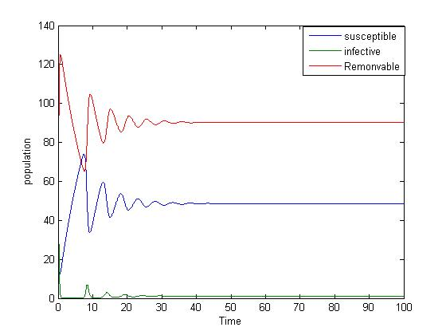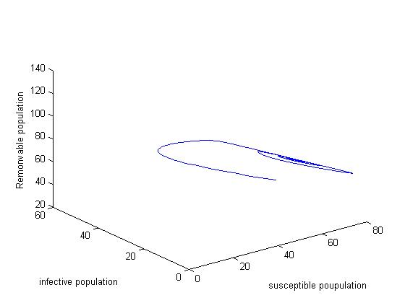

Fig 1.1(A) Fig 1.1(B)

Stable variations and the solution curves are converging to a fixed equilibrium point E(49,1,90).

There is a significant growth in susceptible population and decay in removable population.

**For λ = 0.1& T=5**

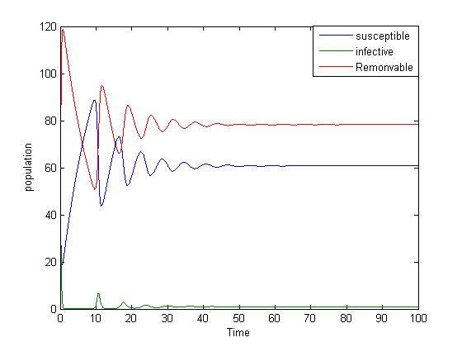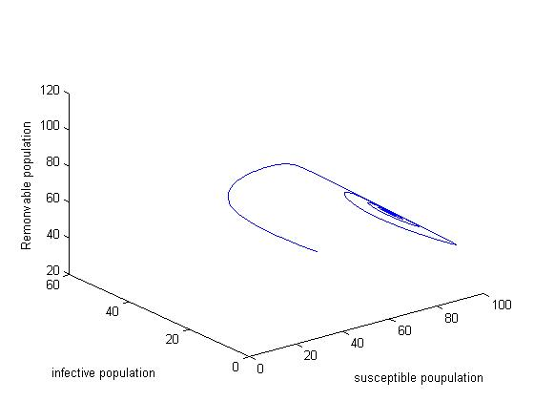

Fig 1.2(A) Fig 1.2(B)

Stable variations and the solution curves are converging to a fixed equilibrium point E(61,1,78).

There is a significant growth in susceptible population and decay in removable population. For fixed λ =0.1 and varying the parameter T from 5 to 25 , there is significant growth in susceptible population infectious population and removable population almost washed out .Hence only susceptible population remain for λ =0.1 and T =25 which is shown in the below plot.

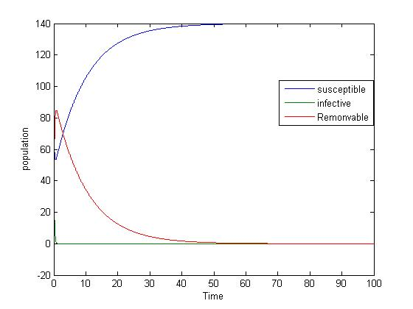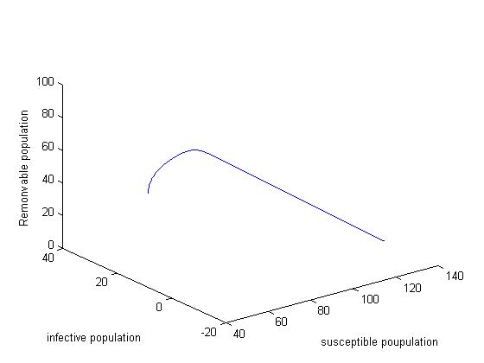

Fig 1.3(A) Fig 1.3(B)

Here only the susceptible population remain reach the maximum bound i.e N=140.

**For λ = 1& T=0.1**

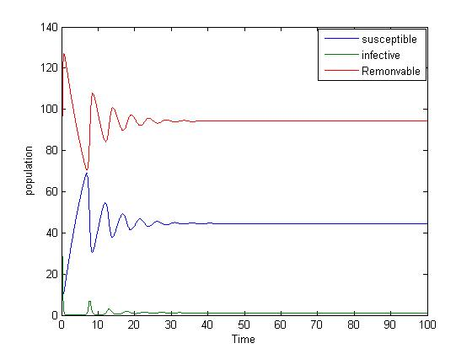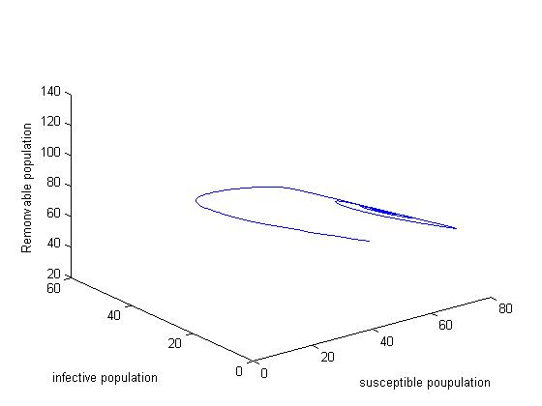

Fig 2.1(A) Fig 2.2(B)

Stable variations and the solution curves are converging to a fixed equilibrium point E(45,1,94).as on T increases from 0.1 to 2 , eventually the infectious and removable population becomes extinct and susceptible population reach its maximum value i.e 140 for λ = 1& T=2.5 .The plot for this values are shown below



Fig 2.2(A) Fig 2.2(B)

**Case (ii) :** Using the kernel weights as  the results are simulated using MATLAB for the following same set of parametric values shown in example1 with different λ and α.

**For λ = 2.5& α =1**

|  |  |
| --- | --- |
| C:\Users\D APPARAO\Desktop\1.jpg | C:\Users\D APPARAO\Desktop\1A.jpg |

Fig 3.1(A) Fig 3.1(B)

|  |  |
| --- | --- |
| Removable and infectious populations are extinct, hence the susceptible population reach its maximum value i.e 140.  **For λ = 2 & α =1**    C:\Users\jntuv\Desktop\1.jpgC:\Users\jntuv\Desktop\2.jpg |  |
| Fig 3.2(A) Fig 3.2(B) |  |

Stable bounded variations makes the system asymptotically stable .Here infectious populations is extinct. Here susceptible population and removable populations converging to the fixed equilibrium point E(122,18) shown in Fig (4.1 ( A&B) ).for λ = 2& α=1 also exhibit same nature in which susceptible population and removable populations converging to the fixed equilibrium point E(81,59).Eventually for λ = 2.5 & α=1 removable and infectious populations are extinct , hence the susceptible population reach to its maximum value shown in fig (3.1 (A& B)) .

**For λ = 1& α =1**

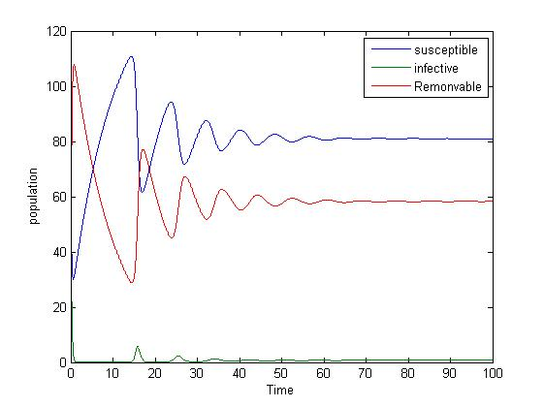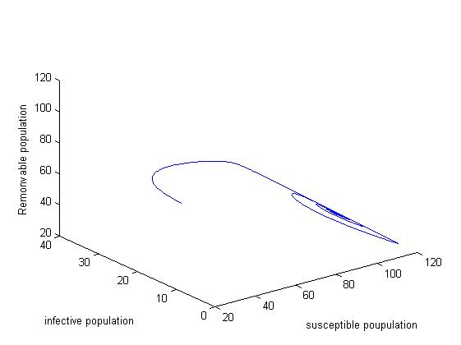

Fig 4.1(A) Fig 4.1(B)

The system is asymptotically stable for λ = 1& α =1 the susceptible and removable population converging to the fixed equilibrium E(81,59) which is shown above fig.

**For λ = 1& α =0.1**

|  |  |
| --- | --- |
| C:\Users\D APPARAO\Desktop\4.jpg | C:\Users\D APPARAO\Desktop\4a.jpg |

Fig 4.2(A) Fig 4.2(B)

For λ = 1& α =0.1 only susceptible populations remains and rest two populations are washed out

**7 .Conclusion:**

A micro parasite model is considered for the investigation which consists of susceptible (x), infective (y) and removable (z) populations. The total population (N) is constant in the view of births and deaths. The distributed type delay is incorporated in the interaction of susceptible (x), infective (y) population. The model is characterized by the system integro-differential equations. We take two types kernel weights and studied the local stability analysis at endemic equilibrium point. The system is locally asymptotically stable if  for both type of delay kernels. Numerical simulation is carried out for two different delay kernels and the dynamics was shown with suitable examples. In both delay kernel strengths with same parametric values shown in example (1) the system exhibits asymptotically stable in nature. The Numerical simulation supports the analytical investigation and the results are summarized and shown below.

**7.1: Results and Discussion:**

For the delay kernel weight of  we observe the following nature

|  |  |  |
| --- | --- | --- |
| **S.No** | **values of λ & T** | **Nature of the system** |
| 1 | λ = 0.1& T=2 | Asymptotically stable and converge to the E(49,1,90) shown in Fig (1.1 A&B) |
| 2 | λ = 0.1& T=5 | Asymptotically stable and converge to the E(61,1,78) shown in Fig (1.2 A&B) |
| 3 | λ = 0.1& T=25 | Removable and infective population extinct , only susceptible population remains shown in Fig (1.3 A&B) |
| 4 | λ = 1& T=0.1 | Asymptotically stable and converge to the E(45,1,94) shown in Fig (2.1 A&B) |
| 5 | λ = 1& T=2.5 | Removable and infective population extinct , only susceptible population remains shown in Fig (2.2 A&B) |

Using the kernel weights as  for λ = 0.1& a=5, we observe the following nature

|  |  |  |
| --- | --- | --- |
| **S.No** | **values of λ & α** | **Nature of the system** |
| 1 | λ =2& α =1 | Asymptotically stable and converge to the E(122,18) shown in Fig (3.1 A&B) |
| 2 | λ = 2.5& α =1 | Removable and infective population extinct , only susceptible population remains shown in Fig (3.2 A&B) |
| 3 | λ = 1& α =1 | Asymptotically stable and converge to the E(81,59) shown in Fig (4.1 A&B) |
| 4 | λ = 1& α =0.1 | Removable and infective population extinct , only susceptible population remains shown in Fig (4.2 A&B) |

In two cases the system is locally asymptotically stable. For the delay kernel strengths of  with (i) λ = 0.1& T=5 (ii) λ = 1& T=2.5 and for  with (i) λ = 2.5& α =1 (ii) λ = 1& α =0.1the parasite cannot maintain itself i.e., in the population eventually dies out the removable and infective class . Only susceptible population remains.

**References:**

1. Anderson, R. M., & May, R. M. (1979). Population biology of infectious diseases: Part I. Nature, 280(5721), 361-367.
2. Anderson, R. M., & May, R. M. (1981). The population dynamics of microparasites and their invertebrate hosts. Philosophical Transactions of the Royal Society of London. B, Biological Sciences, 291(1054), 451-524. **https://doi.org/10.1098/rstb.1981.0005**
3. Bailey, N. T. (1975). The mathematical theory of infectious diseases and its applications. Charles Griffin & Company Ltd, 5a Crendon Street, High Wycombe, Bucks HP13 6LE.
4. Brauer, F., Driessche, V. D. P., & Wu, J. (2008). Mathematical epidemiology (pp. 3-17). Berlin: Springer.
5. Cooke, K. L. (1979). Stability analysis for a vector disease model. The Rocky Mountain Journal of Mathematics, 9(1), 31-42.
6. Daley, D. J. & Gani, J,.(1999) Epidemic Modeling: An Introduction, Cambridge University Press, Cambridge
7. Evans, A. S,.( 1982), Viral Infections of Humans”, 2nd. ed. Plenum Medical Book Company, New York
8. Frauenthal, J. G,.(1980) Mathematical Modeling in Epidemiology SpringerVerlag Berlin
9. Hethcote, H. W. (1976). Qualitative analyses of communicable disease models. Mathematical Biosciences, 28(3-4), 335-356.
10. Karuna, B. N. R.., Narayan, K. L., & Ravindra Reddy, B. (2015). A mathematical study of an infectious disease model with time delay in CTL response. Global Journal of Pure and Applied Mathematics (GJPAM),11
11. Kuang, Y. (Ed.). (1993). Delay differential equations: with applications in population dynamics (Vol. 191). Academic press.
12. Murray**,** J. D. (2002). Mathematical Biology-I:an Introduction. Third edition, Springer publication
13. Nokes, D. J., & Swinton, J. (1995). The control of childhood viral infections by pulse vaccination. Mathematical Medicine and Biology, 12(1), 29-53.
14. Paparao, A., & Narayan, L. K. (2017). Dynamics of a prey predator and competitor model with time delay. International Journal Of Ecology & Development, 32(1), 75-86.
15. Kumar, R., Narayan, K. L., & Ravindrareddy, B. (2017). Mathematical study of epidemic models Ph.D thesis JNTU Hyderabad.
16. Rao, A. D., Vali, K. S., & Paparao, A. (2017). Dynamics of directly transmitted viral micro parasite model. International Journal of Ecology & Development, 32(4), 88-97.
17. Zhou, X., & Cui, J. (2011). Global stability of the viral dynamics with Crowley-Martin functional response. Bulletin of the Korean Mathematical Society, 48(3), 555-574.

**ABOUT THE AUTHORS**



AppaRao Dokala is currently working as an Assistant Professor in the Department of Mathematics at Rajiv Gandhi University of Knowledge, IIIT Srikakulam, Andhra Pradesh, India. His area of research work is Mathematical Modeling (Epidemic Models).He has 10 years of teaching experience.



Kalesha Vali, Shaik is currently working as a Professor of Mathematics in the department of Basic Sciences & Humanities and Social Sciences at JNTUK University College of Engineering, Vizianagaram, Andhra Pradesh, India. He holds Ph.D, M.Phil and M.Sc in Mathematics. His areas of research include Algebra, Lattice theory and Mathematical Modeling. He published number of research articles, authored a Book and guiding candidates for their Ph.D in addition to the guided M.Phils and Ph.Ds.



PapaRao A V is working as an Assistant Professor of Mathematics at JNTUK University College of Engineering, Vizianagaram, Andhra Pradesh, India. He completed his Ph.D in Mathematical Modelling. His area of intersect include mathematical Modeling in Ecology, Biology, Medicine and data sciences. He authored Three books and guiding candidates for Ph.D.